**Opdracht 7 (Individuele opdracht):** realiseer een LED die je bestuurt met Blynk vanaf je smartphone. Volg stapsgewijze onderstaande handleiding.

<https://www.instructables.com/id/Use-ESP32-to-Control-LED-With-Blynk-Via-WiFi/>

Toon vervolgens de ruwe waarde van de 16 bits ADC op je smartphone. Vervolledig eventueel met een ander veld dat de temperatuur weergeeft in graden Celcius.

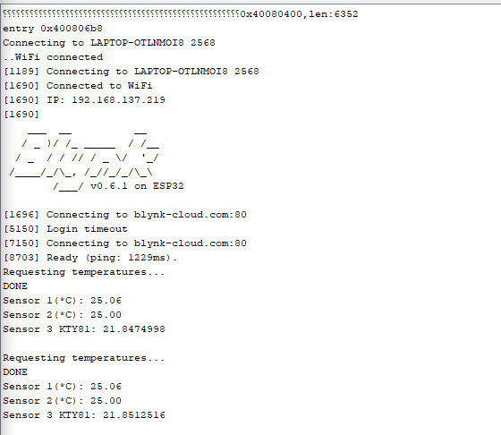

#define BLYNK_PRINT Serial

int pin = 18;

#include <WiFi.h>

#include <WiFiClient.h>

#include <BlynkSimpleEsp32.h>

#include <OneWire.h>

#include <DallasTemperature.h>

#include <Wire.h>

#include <Adafruit_GFX.h>

#include <Adafruit_SSD1306.h>

#include <Adafruit_ADS1015.h>

// You should get Auth Token in the Blynk App.

// Go to the Project Settings (nut icon).

char auth[] = "iyFDjTSp0yOimpvd_AtXzQ7LQ9UHWpWJ";

// Your WiFi credentials.

// Set password to "" for open networks.

char ssid[] = "LAPTOP-OTLNMOI8 2568";

char pass[] = "1756{Bn9";

Adafruit_ADS1115 ads(0x48);

float temp = 0.0;

float temp1 = 0.0;

#define SCREEN_WIDTH 128 // OLED display width, in pixels

#define SCREEN_HEIGHT 64 // OLED display height, in pixels

// Declaration for an SSD1306 display connected to I2C (SDA, SCL pins)

Adafruit_SSD1306 display(SCREEN_WIDTH, SCREEN_HEIGHT, &Wire, -1);

// Data wire is connected to GPIO15

#define ONE_WIRE_BUS 15

// Setup a oneWire instance to communicate with a OneWire device

OneWire oneWire(ONE_WIRE_BUS);

// Pass our oneWire reference to Dallas Temperature sensor

DallasTemperature sensors(&oneWire);

DeviceAddress sensor1 = { 0x28, 0x38, 0x44, 0x9B, 0xB, 0x0, 0x0, 0x10 };

DeviceAddress sensor2 = { 0x28, 0x85, 0x3C, 0x9B, 0xB, 0x0, 0x0, 0xE };

void setup() {

pinMode(pin, OUTPUT);

pinMode(pin, HIGH);

Serial.begin(115200);

delay(10);

Serial.print("Connecting to ");

Serial.println(ssid);

WiFi.begin(ssid, pass);

int wifi_ctr = 0;

while (WiFi.status() != WL_CONNECTED) {

delay(500);

Serial.print(".");

}

Serial.println("WiFi connected");

Blynk.begin(auth, ssid, pass);

if (!display.begin(SSD1306_SWITCHCAPVCC, 0x3C)) { // Address 0x3D for 128x64

Serial.println(F("SSD1306 allocation failed"));

for (;;);

}

Serial.begin(115200);

sensors.begin();

ads.begin();

}

void loop(){

Blynk.run();

Serial.println("Requesting temperatures...");

sensors.requestTemperatures(); // Send the command to get temperatures

Serial.println("DONE");

Serial.print("Sensor 1(*C): ");

Serial.println(sensors.getTempC(sensor1));

Serial.print("Sensor 2(*C): ");

Serial.println(sensors.getTempC(sensor2));

display.clearDisplay();

display.setTextSize(1);

display.setTextColor(WHITE);

display.setCursor(0, 0);

// Display static text

display.println("Sensor 1 dallas:");

display.setTextSize(1);

display.setTextColor(WHITE);

display.setCursor(0, 10);

// Display static text

display.println(sensors.getTempC(sensor1));

display.display();

Blynk.virtualWrite(V1, sensors.getTempC(sensor1));

display.setTextSize(1);

display.setTextColor(WHITE);

display.setCursor(0, 20);

// Display static text

display.println("Sensor 2 Dallas:");

display.setTextSize(1);

display.setTextColor(WHITE);

display.setCursor(0, 30);

// Display static text

display.println(sensors.getTempC(sensor2));

display.display();

Blynk.virtualWrite(V2, sensors.getTempC(sensor2));

int16_t adc0;

adc0 = ads.readADC_SingleEnded(0);

temp = (adc0 * 0.1875) / 1000; // convert ADC value into voltage

temp1 = temp * 10;

Serial.print("Sensor 3 KTY81: ");

Serial.println(temp1, 7);

Serial.println();

display.setTextSize(1);

display.setTextColor(WHITE);

display.setCursor(0, 40);

// Display static text

display.println("Sensor 3 KTY81:");

display.setTextSize(1);

display.setTextColor(WHITE);

display.setCursor(0, 50);

// Display static text

display.println(temp1);

display.display();

Blynk.virtualWrite(V3, temp1);

delay(200);

}